Christmas in the Southern Hemisphere
Christmas is a religious holiday which celebrates the birth of the son of God, Jesus Christ, on the 25th December.
Christmas is celebrated by millions of people all over the world. It is a time of gathering with family and friends. There are some mostly universal traditions, such as decorating houses with lights, trees, candles and having a Christmas dinner. There are also some very unique traditions, specific to certain countries.
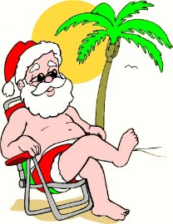
When we think of Christmas, we normally imagine snowy winter landscapes. But it is not like that everywhere in the world. Let's take a look at how Chrismtas is celebrated in the Southern Hemisphere.
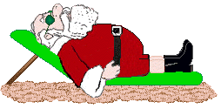

AUSTRALIA
In Australia, Christmas comes at the beginning of the summer holidays! Children have their summer holidays from mid December to early February. The temperature in Australia on Christmas Day can range between 30-40°C.
Australians hang wreaths on their front doors and sometimes go out Christmas carol singing on Christmas Eve. They also decorate their houses with bunches of 'Christmas Bush', a native Australian tree with small green leaves and cream coloured flowers. Some Australian families have the tradition of creating Christmas light displays in their streets for everyone to enjoy.
Bondi Beach is famous for families having their Christmas lunch on the beach.
A typical Christmas menu can include seafood, glazed ham, cold chicken, duck or turkey, cold deli meats, pasta, salads, desserts of all types, fruit salad, ice cream and Christmas treats such as mince pies. Some Australian families follow tradition of a roast dinner and Christmas pudding even in the warm summer weather.
As it is the middle of summer in Australia at Christmas time, the words to the Carols about snow and the cold winter are sometimes changed to special Australian words! There are also some original Australian Carols.
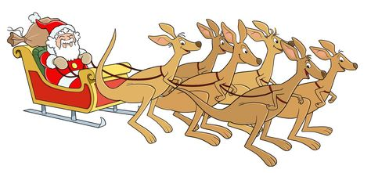
When Santa gets to Australia he changes into a T-shirt, shorts and thongs (flip-flops). He then gives his reindeers a rest, calling on the help of his kangaroo friends or as they are known as the ‘Six White Boomers’ (a popular Australian Christmas carol).

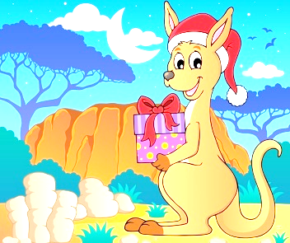
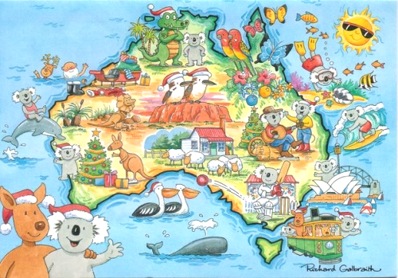
Christmas in the Southern Hemisphere
Worksheet

- Who celebrates Christmas?
__________________________________________________________________________________

- Name some universal traditions.
__________________________________________________________________________________

- Compare Christmas in our (Northern) hemisphere to the Christmas in the Southern hemisphere.

 | Northern Hemisphere | Southern Hemisphere
Weather
Decorations
Food
Christmas Carols
Santa Claus

- Surf the Internet. Find at least five more countries in the Southern Hemisphere that celebrate Christmas.
______________________________________________________________________________________________________________________________________________________________________

LISTENING TASK
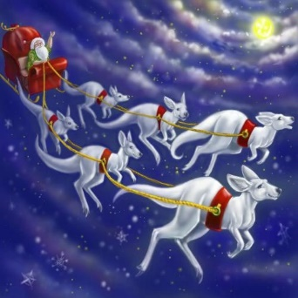
Listen to the popular Australian Christmas carol and circle the correct answer. bit.ly/SixWhiteBoomers
‘Six White Boomers’

1 Joey is
- a kangaroo.
- a boomer.
- a raindeer.

2 To hop up means
- to run away.
- to climb up.
- to get out of.

3 Where did Joey find his place on Santa's sleigh?
- In Santa's lap.
- Next to a bag of toys.
- In a bag of toys.

4 To unharness means
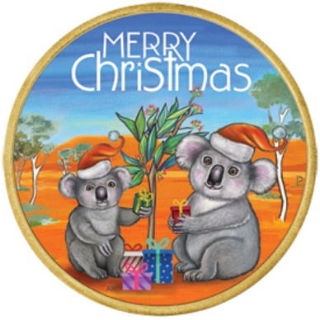
- to release.
- to capture.

5 A boomer is
- a raindeer.
- a koala.
- a white kangaroo.

6 After a while, Santa started feeling
- cold.
- hot.
- just right.

7 When does Santa give presents to Australian children?
- on Christmas Day.
- on Boxing Day.
- on Christmas Eve.

8 What does the Santa mean by 'an extra trip'?
- An expensive trip.
- An additional trip.
- An ordinary trip.

9 To bound up and down means
- to jump up and down.
- to go left and right.
- to fly up high.

10 What is the English word for 'tobolac'?
- A pouch.
- Snug.
- A double run.

LISTENING TASK 2
Listen to the Australian version of Jingle Bells and fill in the blanks with the correct Australian slang word.

https://bit.ly/AustralianJingleBells
Dashing through the ______________________ in a rusty ____________________
(countryside, the Outback) (open back van)
Kicking up the dust, ________________ in the _______________.
(cool box) (trunk)
______________________ by my side, Singing Christmas songs
(Australian breed of dog)
It’s summer time and I am in my ___________________, shorts & _______________________.
(sleeveless vest) (flip flops)

OH, JINGLE BELLS, JINGLE BELLS, JINGLE ALL THE WAY
CHRISTMAS IN AUSTRALIA ON A ____________________ SUMMER’S DAY.
(very hot)
JINGLE BELLS, JINGLE BELLS, CHRISTMAS TIME IS BEAUT
OH WHAT FUN IT IS TO RIDE, IN A RUSTY HOLDEN UTE.

Engine’s getting hot, dodge the kangaroos.
Swaggy climbs aboard, he is welcome, too.
All the family is there, sitting by the pool,
Christmas day, the _______________ way by the barbecue!
(Australian)
OH, JINGLE BELLS, JINGLE BELLS…
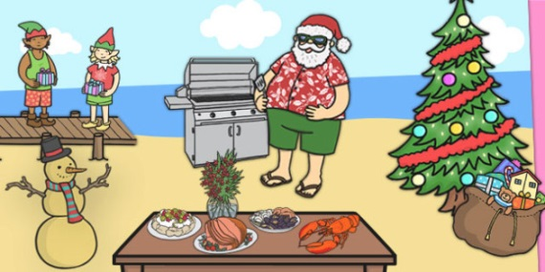
Come the afternoon, grandpa has ___________________,
(a nap)

The kids and uncle Bruce are swimming in their clothes.
The time comes round to go, we take a family _____________________,
(photo)
Then pack the car and all ____________________ before the washing up.
(leave quickly)
OH, JINGLE BELLS, JINGLE BELLS…

bit.ly/JingleBellsAlfa – link to traditional Jingle Bells
Listen to traditional Jingle Bells song. Compare it to the Australian Jingle Bells.

Similarities | Differences
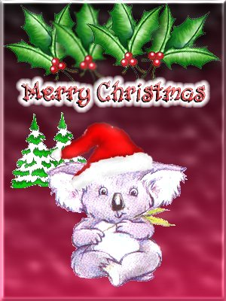
Which version do you like more? Why?
__________________________________________________________________________________________________________________________________________________________________________________________________________________________________________________________________________________________________________________________________________________________________________________________________________________________________________________________________

